NAME : Shriya Ramya Mohan EXP : 5
Roll no: 241901106

CUSTOMIZED PING COMMAND TO TEST SERVER
CONNECTIVITY
AIM:
To design a customized ping program that checks the connectivity
between a client and a server by sending packets and measuring the
response time.

ALGORITHM:
1.Start the program and input the server IP or
hostname.
2.Send a test packet (ICMP or TCP) to the server.
3.Wait for a reply within a specified timeout.
4.If a reply is received, calculate and display the round-trip time (RTT).
5.If no reply is received, display “Request timed out.”
6.Repeat the process for a given number of times.
7.Display summary results (packets sent, received, lost, and average
RTT).

PROGRAM:
import socket
import time
host = "google.com" # you can change
this port = 80 # HTTP port
count = 4 # number of pings
for i in range(count):
try:
s = socket.socket()
start = time.time()
s.connect((host, port))
end = time.time()
s.close()
print(f"Reply from {host}: time={(end-start)*1000:.2f}
ms") except Exception:
print("Request timed out")
if times:
print("\nMin RTT =", min(times), "ms")
print("Max RTT =", max(times), "ms")
print("Avg RTT =", sum(times)/len(times), "ms")

OUTPUT:
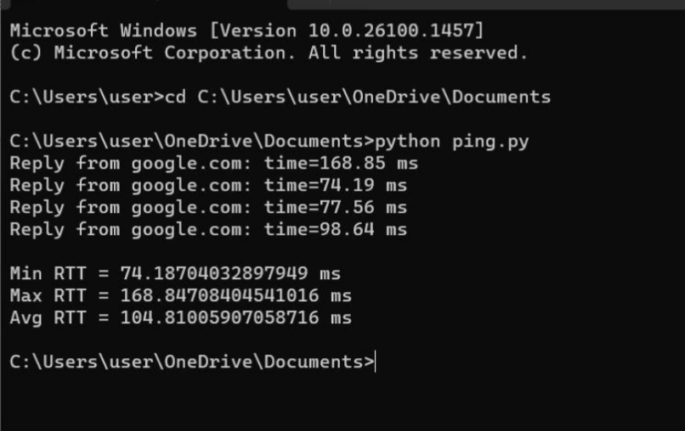
RESULT:
Therefore, customized ping commands was implemented and
server connectivity was tested

